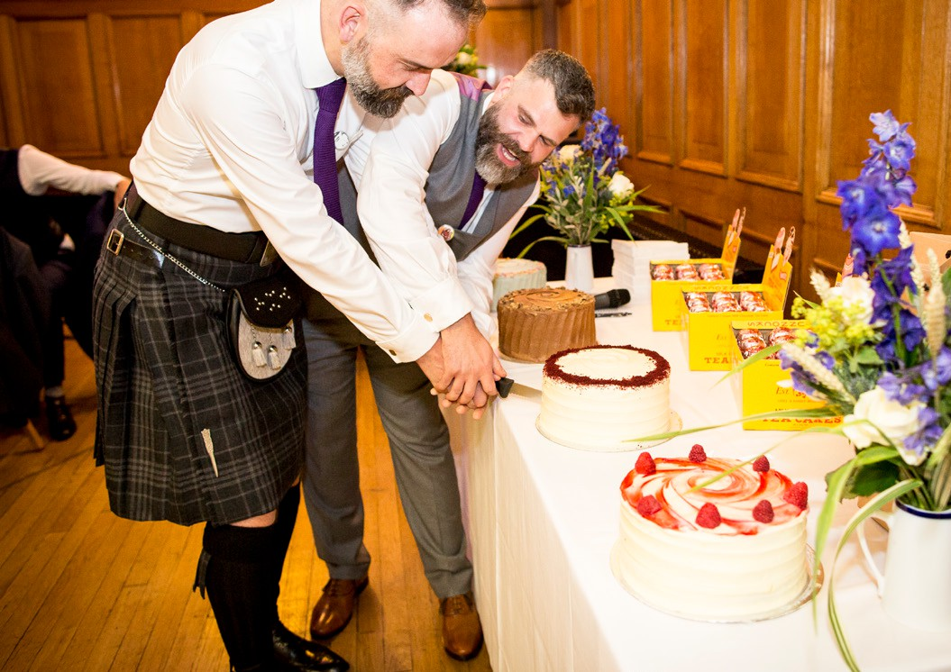






CELEBRA TION P A CKA GE
Supporting Wedding Pack
islingtonassemblyhall.co.uk/weddings Managed by Islington Council
1

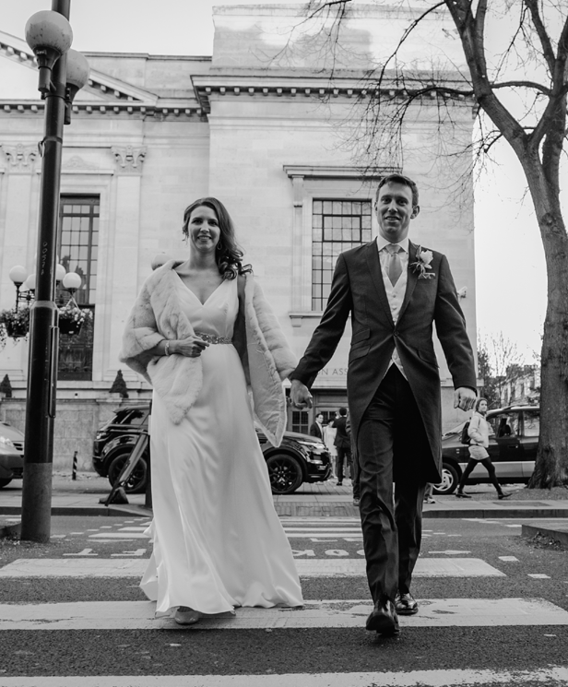
2

Contents

- FAQs
- Celebration package details
- Dos and don’ts
- Catering checklist
- Staffing information
- Audio requirements
- Layouts & furniture measurements
- Information for the venue
- A few extra bits!
- Post wedding


FAQs

Do all costs include VAT?
Yes, all costs include VAT.

- How many guests can we have in total? 176 fully seated at round tables. If you want a space for a dancefloor, 130 guests fit nicely but you can always take tables away after the meal to create space.

How many guests around each table?
Eight to sit comfortably, nine at a push.

- Can we hire the hall before 2pm? Yes, you can hire the hall at £245 per hour.

Can we have the hire later than midnight?
Yes, we can apply for a late licence so your party can go on until 2am for £825. Live music can go on until midnight and then recorded music after that. The hall needs to be clear by 2.30am.

What time should we book our ceremony?
As the start of your hire is 2pm, if you are getting married in the Town Hall, we usually recommend around 3 or 4pm, depending on how long you think your caterer will need to prepare.

What happens if we need to change the date of our wedding or cancel completely?
To confirm the event, we require a non- refundable and non-transferable £500 deposit. Unfortunately, if you want to change the date or cancel your wedding we would retain your deposit. If you do not comply with the duties of these terms and conditions, the Islington Assembly Hall team may cancel the Event and retain the Deposit.

If you provide less than six months’ notice to cancel the Event, the Deposit will be retained and the remaining Hire Fee shall be invoiced.
If the Islington Assembly Hall team cancels the Event at any time (other than due to Force Majeure as outlined in your agreement), the full Deposit and any other payments made will be returned to you in full.
Please note, we will not be liable for any inconvenience or loss caused to any party as a result of cancellation or termination of your event.

When do you need to pay the final balance?
The final balance is required four weeks before the event.

On the day of the event, when do we have to be clear of the venue?
You and your guests must be clear of the venue at the specified end of hire in your contract with us. This does mean completely clear of all suppliers as well so please organise collection of any decorations, crockery etc. to be earlier than your end time. If anyone from your

3

FAQs

party or suppliers are still in the hall after the agreed time, you would be charged an hourly rate of £300.

Anything left in the venue will be thrown away unless otherwise specified.
Occasionally we can hold on to a few bits for collection the following day, but this is not guaranteed and must be organised with us in advance.

What is expected of us at the end of the event?
The rubbish put in the appropriate waste bags (available from the Islington
Assembly Hall team) and deposited in the correct area as shown by us on the day
of the event.

If the kitchen is not left in
an ‘as found’ condition, Islington Assembly Hall team retains the right to charge the hirer for additional cleaning if deemed necessary by the Islington Assembly Hall team.
The Islington Assembly Hall team does not take any responsibility for any items brought onto or left on the premises or for any personal possessions brought onto the premises. To the fullest extent permitted by law, Islington Assembly Hall shall not be liable for any loss or damage
to property incurred by you or your guests.

Can we hire the balcony?
The balcony is off-limits during the hire with the exception of your photographer and the hirer, should they want to get any photos up there.

Can we sell food and drink at our event?
All the drinks need to be sold through Islington Assembly Hall. These will either be pre-paid for by you or purchased by your guests on the day of your wedding. Please note we do not have an off-license permit, and you won’t be able to take any alcohol out of the venue.
All food must be given away for free to your guests.

It is up to you to make sure your guests are drinking responsibly. If, on the day of the event, our duty manager deems that any of your guests need to stop drinking, their instructions must be adhered to. If their instructions are not adhered to, the guest in question may be asked to leave the venue.

Do we need to get insurance?
We encourage you to get appropriate insurance cover of £5,000,000 to indemnify the venue against claims which may be made against it in respect of loss or damage which the venue may suffer.
Such insurance should also cover the risk of bodily injury or death to you, your
guests/delegates, your contractors, agents or licensees and members of the group or any third parties. This excludes any such loss, damage, injury, or death as may be caused by the act, default or negligence
of the venue.

4

Our Celebration package starts from £9,000 and includes:
Extra security
One security included in wedding packages, more required for over 130 guests.
£49 per hour per person, 5 hr minimum
Extra charges for services:
Late licence
2am music finishes, 2.30am hall clear
£825
Venue tablecloths (white)
£12 per tablecloth
Electric chafing dishes
Your caterers can bring their own in.
If your caterers bring in flame chafing dishes, we may insist on them using ours instead and you would be charged for this.
£200 for six chafing dishes
Access before 2pm £245 per hour
Monitor engineer £330
For bands with over four members / multiple bands.
- Hire of the hall from 2pm - midnight
- The hall set up with our tables and chairs to suit your requirements, following pre-event meetings
- A dedicated events coordinator to help you leading up to your big day
- A duty manager on the day of your wedding
- Use of our PA system, lighting rigs and engineers to work them
- Use of the kitchen
- Use of a private dressing room
- Door staff by the entrance/exit
- Our house drinks package and glassware for up to 130 guests
- Additional drinks packages charged at £28 per head.
- Our bar open, staffed and stocked
- VAT
- Two tickets to a concert of your choice in the venue during the first year of marriage

5

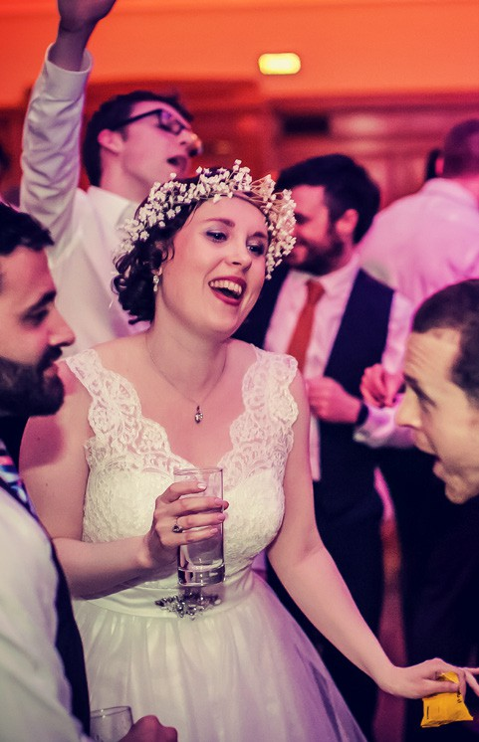


Dos and Don’ts when hiring the Assembly Hall:

Dos
- We encourage you to have a live band or DJ. It gives us a chance to show off what we do best! We have a stage with lights and a fantastic PA system. We have sound and
light engineers to help sound check and make your wedding really pop!
Please note, if you have multiple bands or a band with over four members you would require a monitor engineer from us.
This would be at an extra charge, please ask the IAH team for details.
- Bring a knife to cut your wedding cake or organise this with your caterer

Don’ts
- Don’t stick anything to any surface in the venue. Please only tie or use blu tack. Nothing can be stuck to our wallpaper
- You cannot obscure any health and safety related signage
- You cannot use any confetti or glitter in the hall (this includes on the tables)
- Don’t use centre pieces that are tall and thin. Our original 1920’s sprung dancefloor is fantastic when you start dancing but could make your lovely flower piece topple over
- Don’t bring in anything that has a flame. This includes candles and flame chafing dishes from your caterers
- Don’t block any of our fire exits
6

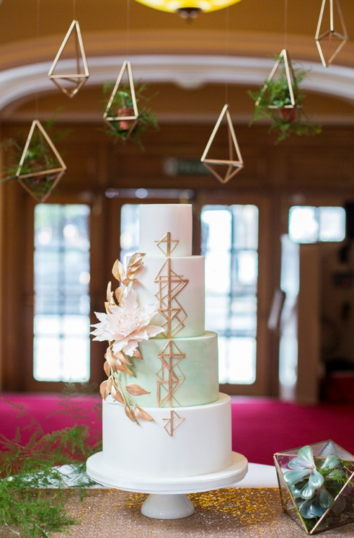


Catering Checklist

You have the flexibility to bring in the catering company of your choice, subject to checks we carry out to help make sure you and your guests have an enjoyable experience.

Before you confirm your booking with your caterer, we require proof of:
  - of compliance with the Food Safety Act 1990 and other relevant legislation
  - that they have a food hygiene rating of 3 or above
  - of implementation of an appropriate HACCP-based food safety management system, as detailed on the Food Standards Agency website
  - of employers’ liability insurance.

When choosing your caterer, you should consider whether they can provide the service you require while meeting the terms and conditions of hire to which you have agreed. You must also make sure they are able to come to the venue in good time before the day of your event to meet with the Islington Assembly Hall team and familiarise themselves with the facilities.

7

You should make your prospective caterer aware of the following information in your initial discussions:
- We do not allow any raw meat in the kitchen.
- We do not allow any nuts in the venue, due to staff allergies.
- Our kitchen is for warming / serving only, so all cooking should be done off site prior to arrival.
- The area outside our kitchen is a fire escape and must not be used for preparation, serving or storage. If your caterers advise they will require extra space to meet your
requirements, please put them in touch with the Islington Assembly Hall team.
- No ovens or other heating equipment are allowed to be
brought in

No flames are allowed anywhere in the building including paraffin wax, bain-marie gels, candles or gas cannisters.
- Chafing dishes are allowed as long as they are electric and are checked – see next point below.
- Any electrical items brought in should have a valid PAT test sticker.
- After the event, the cleaning of the kitchen is the responsibility of the caterer.
- Your caterer should bring their own cleaning products. If the kitchen is not left as the caterer found it, £250 will be charged to you, the hirer.
- There is space for dropping off / collection of items. Please discuss this first with the Islington Assembly Hall team.
- All waste should be disposed of in the correct bins. We recycle card, paper, tin, glass and food waste. The venue duty manager can provide your caterers with bags.
- The hirer and his/her caterer must ensure that no cooking oil or any similar substance is poured down any drain inside or outside the hall premises during their function.

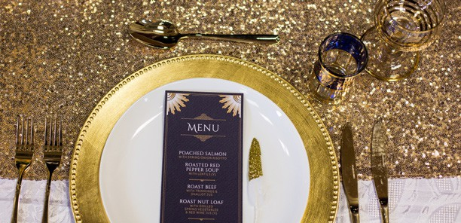
8

We have the following equipment in our kitchen:
- 4 x Hot cupboards
(w - 80cm, h - 60cm, d - 40cm)
- 1 x Heated Gantry
- 1 x Lincat Cooker
(w - 50cm, h - 40cm, d - 40cm)
- 4 x Electric Hob plates
- 2 x Samsung 1,600w microwaves
- 1 x Double-width Williams fridge.


AUDIO / VISUAL TEAM:
- One audio engineer
- One lights and visual engineer
If you have multiple bands or your band has more than four members, you will require a monitor engineer. This is at the discretion of our Technical Manager and the charge is based on the hours they will be required. Please ask the IAH team for more details.
SECURITY:
- One security (another security is required if you have over 130 guests)

Staffing

With our Celebration package, you will have the following venue team on hand to assist throughout your big day:
- Duty manager - This person will be on hand to be the point of contact between the wedding party and the venue. They will help keep the schedule and communicate with the bar staff and the tech team any issues or changes to the schedule on the day. You can nominate one other person in your wedding party to be the point of contact with this person so you can concentrate on enjoying the day!

BARS:
- Bar manager
- Two bar staff to serve your guests from behind the bar
- Two floor staff collecting glassware and bringing out the toasts according to the schedule
- One glasswasher
This covers a wedding up to 150 people, if the couple feel more staff might be needed for a more bespoke service, we can increase the staffing levels. Any additional staff will be charged at £45 per hour and a minimum of 5 hours per additional staff member is required.
9

Liquor and other drinks arrangements

Wine
Murviedro Fauno Blanco (Viura, Sauvignon Blanc)

The Celebration package includes our house drinks for up to 130 guests. This includes:
Durello Spumante Brut ‘Palladiano’
Cape Heights Chenin Blanc, Western Cape
The Cloud Factory Sauvignon Blanc, Marlborough
La Val Orballo Albariño
Domaine de la Motte Chablis
Tierra Alta Merlot
Turno de Noche Malbec
MOKOblack Pinot Noir, Marlborough
Ontañón Rioja Reserva
Domenico de Bertiol Prosecco di Valdobbiadene
Spumante Extra Dry
Le Dolci Colline Prosecco Spumante Brut
Domaine de la Vieille Tour Rosé, Côtes de Provence
Château Mayne-Vieil, Fronsac
Showdown ‘Man with the Ax’ Cabernet Sauvignon
Conviviale Montepulciano d’Abruzzo
Sierra Grande Cabernet Sauvignon
Bricco Battistina Gavi
L’Ormarine Duc de Morny, Picpoul de Pinet
Les Oliviers Chardonnay, Pays des Côtes de Gascogne
Los Otros Pinot Grigio
Murviedro Fauno GSM (Garnacha, Shiraz, Monastrell)
- Half a bottle (375ml) of wine either house red (Shiraz) or house white (Sauvignon)
- One glass of prosecco (175ml) for the guest’s arrival
- One glass of prosecco (175ml) for the toast
- Additional drinks packages can be purchased for
£28 per head.

You can choose whether you want a 50/50 split of red and white or if you want to adjust according to your menu/time of year/ preference.

Our staff will put two bottles of wine on the table and then add the next ones once those have been finished.

Please note, we do not have ice buckets. If you want these, you will need to bring them in yourself.

Our premium house package is charged at £33 per head and includes our Picpoul de Pinet and Montepulciano d'Abruzzo. Other wines are available on request, prices will be based on the order closer to the big day.

We are happy to do a wine tasting with you if you would prefer something different to our house package offering. Please call the team to arrange a time for this. For the tasting, you have our house wines and prosecco which are the first three options, and then we can order two more red and two more white from the list for you to taste. Full wine list available upon request.

Veuve Clicquot Yellow Label Brut Champagne 75cl

10

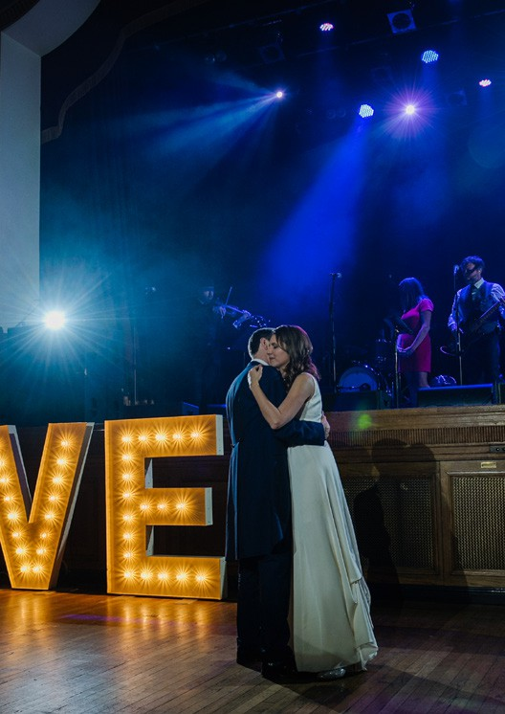



Audio-Visual Requirements

We require the contact details for your band or DJ. Our Technical Manager will get in touch with them to get the information we require.

A few things to discuss with your band/DJ:
- Confirm how many members there are in the band, what instruments they play and how many vocalists there are.
- Ask if they want to sound check. If they want to sound check, this needs to be started at least an hour before your guests arrive on the day. If your band/DJ does not want to do a sound check, we can do a line check. This is not as thorough and would mean our audio engineer would need to adjust the levels as the band start performing.
- We have a lot of equipment here for bands to use including a PA system, mics and a lighting rig. They can get in touch with our Technical Manager, Tom Watt at the following email address to let us know their requirements; Thomas.watt@islington.gov.uk
- We have CDJ100s for DJs, but please note, they are not USB compatible.

If you are wanting to use playlists from an iPod or Spotify playlist (or something similar), let us know. It would be ideal for the
11

band/DJ to have control over this but if they can’t, our engineers can do this. You will need to do the following:
  - Make sure all playlists are available offline
  - Make sure there are no adverts breaks
  - Name all the playlists really clearly so they match your schedule
(e.g. GUESTS ARRIVE – NON-SHUFFLE or DURING DINNER - SHUFFLE)
  - Bring a compatible charger

If you wish to use any technical equipment that does not belong to the Islington Assembly Hall, you must inform the Islington Assembly Hall team at least 14 days in advance of the Event. The Islington Assembly Hall team reserve the right to decline any equipment that they believe is inappropriate, unsafe
or could exceed our sound decibel limit.
A member of the Islington Assembly Hall team will monitor sound levels throughout the Event. If any member of the Islington Assembly Hall team requests the volume or bass level of the sound equipment is reduced, it is the responsibility of the hirer to reduce the sound levels immediately. The decision
of the Islington Assembly Hall team in these
circumstances is final and you shall not attempt to override any such decision.

Where you, or your suppliers, wish to use your own electronic equipment, you agree to have proof of valid PAT testing for all equipment before installation. If the
equipment is found not to be PAT tested, the Islington Assembly Hall team will require such equipment to be PAT tested or removed from the venue. Any decision about whether additional technical equipment can be used will be at the sole discretion of the Islington Assembly Hall team. Where such additional equipment is absolutely essential to your Event, you are responsible for raising this prior to it becoming a Confirmed Booking.

Hirers are permitted to use video camera equipment and/or slide projectors in the hall provided that any trailing leads of the equipment are positioned and secured to the floor in a safe manner to the satisfaction of Islington Assembly Hall staff present on the day.

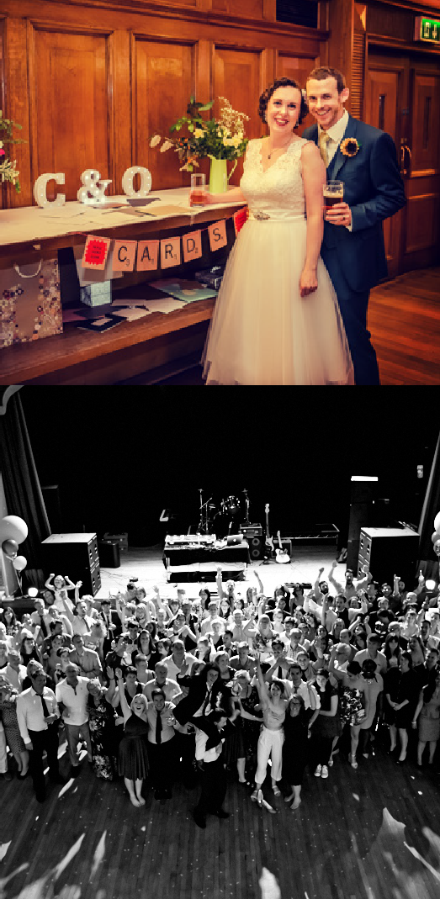

12

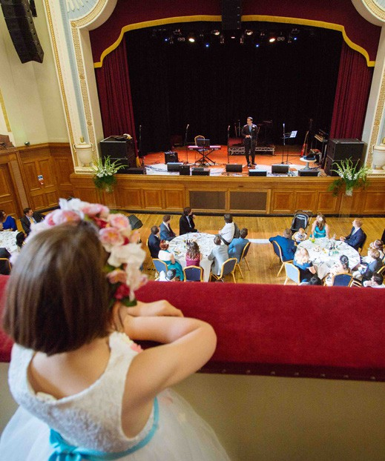

13

Some useful measurements for our furniture:
Large cabaret tables = 1.5m (diameter) Small cabaret tables = 90cm (diameter)
Trestles = 180cm (L) by 75cm (W) by 74cm (H)

 Layouts

We are a flexible space and we provide the tables and chairs for your big day. Below are just a few ideas on the layout that can be adjusted depending on how many guests you have and what your requirements are. With the Celebration package, we will provide the furniture for you and set the tables and chairs out to your requirements.

If you have over 130 guests, it is likely that you will need to consider moving tables out of the way to create space for a dance floor.

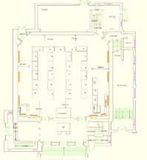
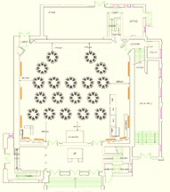

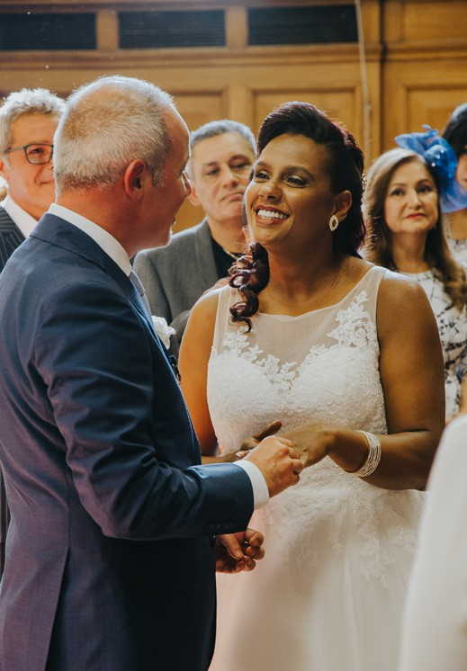


Information for the venue

You will be able to visit the venue twice after confirming your big day with us. Please bring along any suppliers that need to see the venue during these meetings. The last meeting will be a maximum of four weeks before your big day in order to finalise the last details.

Some of the basic information we will require from you:
- The number of guests you are expecting including the number of children
- A schedule for the day from your hire start time until your hire end time
- Confirmation of how many chairs and tables you require
- Contact details for your band or DJ
- Details of your caterers plus the signed catering checklist
- Confirmation of how many drinks packages you want from us (minimum of 130)
- Whether you want our table cloth service

14


A few extra bits!

Licenses and regulations etc.:
You must observe all the regulations relating to the use of the premises as laid down by the Licensing Authority, of which full details can be referred to at: https://www.gov.uk/ government/uploads/system/uploads/ attachment_data/file/418114/182- Guidance2015.pdf

You need to also comply with and observe all statutory provisions, bylaws and regulations applicable to the hiring or the purpose of hire. You will be liable for payment of all
fees connected with Occasional License applications and other associated fees. General guidance on Licenses and Regulations can be obtained from the Islington Assembly Hall team.

Health and safety:
Any member of the Islington Assembly Hall team or Licensing Authority shall be entitled to enter any part of the premises hired, and the hirer shall give instructions for their admission.
Your suppliers must keep all emergency exits free from obstruction at all times during the Event.
Your suppliers must familiarise themselves with any relevant Health and Safety advice provided by the Islington Assembly Hall.
Health and Safety incidents or accidents are to be reported to a member of the Islington Assembly Hall team and followed by an emailed report by the hirer to the Islington Assembly Hall team.

General:
You will undertake and agree to hold the Islington Assembly Hall team harmless and indemnified against all claims, damages, charges, costs and expenses which may be incurred or which may arise in consequence of the premises being let to you or in consequence of you or your employees failing at any time to comply with these conditions, or the rules of the Licensing Authority with regard to the Management of Places of Public Entertainment or otherwise.
Any expenses which may be incurred by Islington the Assembly Hall team as
aforesaid including insurance against such risk shall be immediately repaid by you on demand, failing which we shall be at liberty to institute appropriate proceedings for the recovery as a civil debt.

15

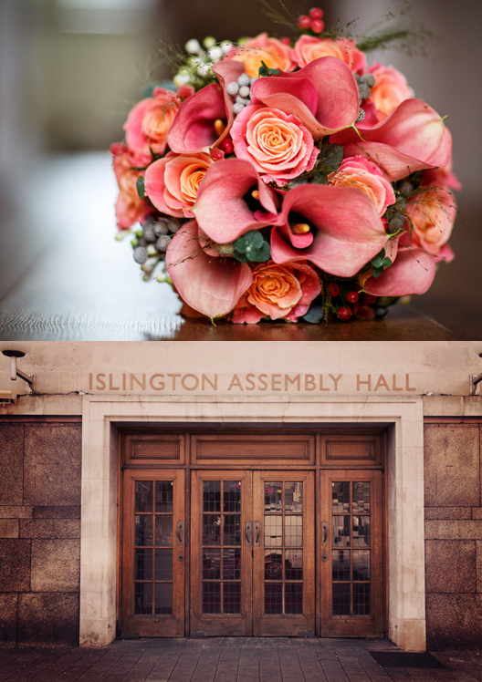

Post wedding
After the wedding, remember you have the two free tickets to a gig of your choice in your first year of marriage. If you keep an eye out on our event listings or sign up to our mailer (http:// islingtonassemblyhall.co.uk/sign-up) so you don’t miss any new announcements, simply email assemblyhall@islington.gov.uk when a show comes up that you like the look of.
It would be great to get a review on our wedding Facebook page as well! It is vital for us to get these to promote our business so it would be lovely to get your thoughts on the planning of the big day and how the day itself went.
It would be amazing to see some photos of the hall if your photographer has any! We know it takes
a few weeks to edit them but if we could get the details of your photographer, we can liaise directly with them for these, if you don’t mind. It really helps other couples to visualise what can be done in the space.
16

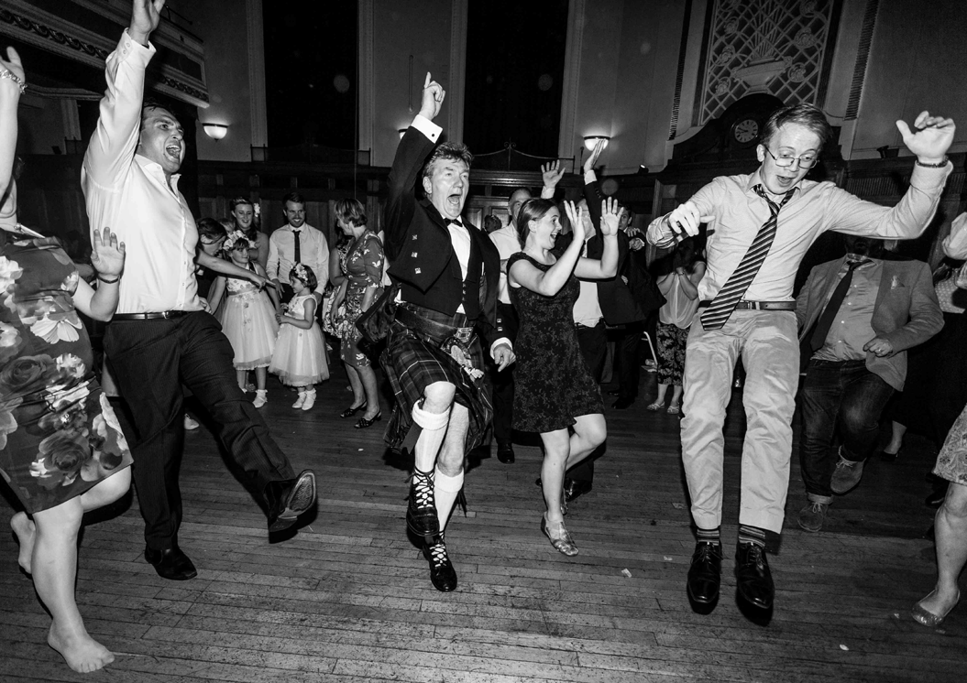







Upper Street, London N1 2UD assemblyhall@islington.gov.uk 020 7527 8900
islingtonassemblyhall.co.uk/weddings

Like and follow us for wedding inspo and to get exclusive offers for your big day!

