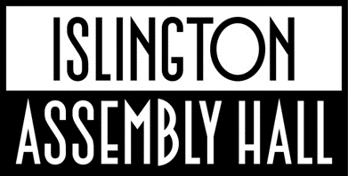
Upper Street, London N1 2UD
020 7527 8900
www.islingtonassemblyhall.co.uk
TECH SPEC

VENUE STAFF
Tom Watt - Technical Manager
07925 034565
tom.watt@islington.gov.uk

Lucinda Brown - Head of Islington Assembly Hall
020 7527 6344
lucinda.brown@islington.gov.uk

Louie Staniland - Assistant Venue Manager
020 7527 2311
louie.staniland@islington.gov.uk

Marina Ibileye - Senior Events Coordinator
020 7527 4346
marina.Ibileye@islington.gov.uk

Dave Cameron - Events Coordinator
020 7527 3067
dave.cameron@islington.gov.uk

Iain Scott - Events Coordinator
020 7527 2745
Iain.Scott@islington.gov.uk

Bizu Yaregal - Ticketing and Marketing Assistant
020 7527 3001
bizu.yaregal@islington.gov.uk

Sammy Winters - Bars and Duty Manager
020 7527 4277
samuel.winters@islington.gov.uk

Ali McCreadie - Assistant Bars and Duty Manager
020 7527 4277
alastair.mccreadie@islington.gov.uk

Bianca Cordeiro - Assistant Bars and Duty Manager
020 7527 4277
Bianca.Cordeiro@islington.gov.uk

Alex Nattrass - Venue Administrator
020 7527 4207
alexandra.nattrass@islington.gov.uk

Matt Rickelton - Events & Operations Assistant
020 7527 7442
matthew.rickelton@islington.gov.uk

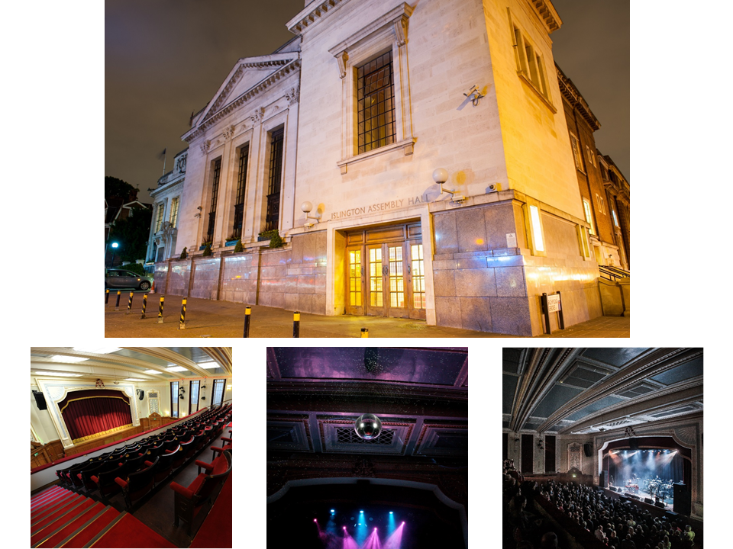

GENERAL INFO

dB LIMIT
100dB(A) leq over a one-minute average with peaks of 102dB(A).
The venue PA (which may not be substituted for any other system) is designed to comply with the venue licence.

CAPACITY
950 maximum sellable capacity
732 GA standing / 218 GA seats/standing in balcony
(16+ venue)

FULLY SEATED
433 sellable capacity (with FOH at back of hall, below balcony, cap rises to 452)
230 (249) GA seats downstairs / 203 GA seats in balcony

CREW
As the venue is Grade II listed, and because of its attachment to, and shared loading entrance with, Islington Town Hall, all crew must be booked through the venue.
Please contact us for a quote.

PARKING
There is parking available for up to 5 cars OR two vans OR one tour bus from load-in to load-out (we can often arrange overnight parking of busses, please discuss, usually the space is available from 2am until 2am the following morning).
This must be booked in advance, please supply the registration details. There is no other parking at the venue except for loading/dropping-off. See parking map below.
Useful site for finding parking in the area: www.en.parkopedia.co.uk

BUS POWER
32A single phase (blue) power is available upon advance request.

POWER
Our electricity is approx 230V 50Hz. Outlets are 13a UK type “G” or CEEform. All electrical equipment brought into the venue should have a valid PAT certificate. Adapters and transformers for other plug types (Edison, Shuko etc) aren’t supplied by the venue.

FIRE SAFETY CERTIFICATES
Fire safety certificates should be made available for all backdrops, drapes, set pieces etc. In the absence of fire safety certificates we can agree to test items (by setting fire to a sample in a controlled setting) - any fabric/material that either holds a flame or you are unable to provide a sample for testing, won’t be permitted on stage.

PYROTECHNICS
The use of pyrotechnics or any open flame is not permited in the venue.

CONFETTI
Foil confetti can be used, there is a clean up charge (£500 +VAT). Paper confetti is not permitted as it stains the wooden floor. Check Co2 restrictions if applicable.

AUDIO EQUIPMENT

PA SYSTEM
12x JBL VTX-A8 (main left/right array)
2x JBL VTX-A8 (stage level lip fill)
8x JBL B18 (Subs)

Please note the system is configured left/right/front fill/sub, the inputs are analogue XLRs, located stage left.

AMPLIFIERS & PROCESSORS
5 x Crown I-Tech 4x3500HD Amplifiers

FOH CONTROL
Allen and Heath dLive S5000
DM48U Ultra FX MixRack

FOH AREA
FOH is set up on 4m x 2m riser (20cm high) with attached barrier. This area cannot be extended any further and must accommodate all house and touring control equipment. Please note for seated gigs the FOH area will be at the back of the hall, under the balcony, unless agreed in advance.

MONITOR CONTROL
Allen and Heath dLive-S3000
DM48U Ultra FX MixRack

MONITORS
9 x JBL VTX M20 Monitors
(including listen wedge)
1 x JBL VTX B15G Sub
3x Crown I-Tech 4x3500HD Amplifiers
(We can accommodate up to 8 wedge mixes + sub + listening wedge)

MICROPHONES
4 Shure Beta 58
8 Shure SM 58
3 Shure Beta 57
6 Shure SM 57
3 AKG C451B
2 AKG C414 XLS
1 Sennheiser MD421
1 Shure Beta 91A
1 Shure Beta 52A
1 Audix D6 Kick
2 Sennheiser E606
6 Sennheiser E904
1 Audix i5

Please note we do not have wireless microphones or in-ear-monitors.

MIC ACCESSORIES
15 Tall Boom Microphone Stands
12 Short Boom Microphone Stands
1 Round Base Stand
Van Damme microphone cables and stage boxes.

DI BOXES
8 BSS AR133 active
1 Radial J48 active
1 Radial PROD2 stereo

MULTICORE
We do not have a FOH analogue multi system. If touring FOH or monitor control, please discuss with venue in advance.

We have 2 spare CAT6 lines from stage to the rear of the hall, but they terminate in wall panels, so we recommend touring productions supply their own multi.

LIGHTING EQUIPMENT

LIGHTING CONTROL
Avolites Quartz with Titan Mobile wing.
(Currently on Titan 18).
3 x DMX Lines.
Two belong to the house rig and a third is available between FOH and stage for touring floor packages.

LIGHTING FIXTURES
See plot for more info.

6 x Martin Mac Quantum Washes
6 x Chauvet Rogue R2X Spots
4 x Martin Mac Aura XB (side and key light)
2x Martin ERA 400 Performance WRM (profile light)
5 x Martin ELP WW (19° lens)
12 x Martin VDO Atomic Dot WRM
(Configured separately as “ACLs”)
8 x Martin VDO Atomic Dot WRM
(Configured in 4 pairs as 2-cell blinders with 60° diffusers)
2x Le Maitre MVS hazers

POWER
Power available for touring production:
1 x 32A 3 phase supply (5-pin) CEEform located on stage (stage left) – with variable RCD, hirer must supply competent operator.

PROJECTOR
Panasonic PT-RZ12K (3 chip 12,000 lumen laser projector).
ET-D75LE30 2.4-4.7:1 Lens

-Use of the projector must be agreed in advance of show day.
-The screen at the back of stage is 6m wide and the picture ratio is 16:9. The bottom of the screen is 1m above the stage floor.
-We do not provide any playback devices or staff to support the projector other than our LD switching
it on and showing the touring party where the HDMI connection is (either on stage or FOH). So, the touring party need to bring a laptop with any content on, and someone to operate it.
-There is no additional charge for using it, but use must be agreed in advance
-The signal is sent to the projector with HDMI over CAT6 boxes or by SDI.
-It is located in the projector room at the back of the balcony.
-The curtain tab above stage (beneath the proscenium arch) obscures the view to the back wall at about 5m.
-If people on the balcony stand and wave their hands above head height, it can be visible on the screen.
-If the venue screen is being used; the curtains at the back of stage must be open and we can’t hang any backdrops.

MISCELLANEOUS
4 x riser sections are available, each at 2m (w) x 1m (d) 38cm (approx) high.

1 x DJ table at 2m (w) x 0.5m (d) x 1m (h).

Stage dimensions at widest point: 10.7m(w) x 6m(d) x 1.4m(h).
Useable area for sight lines is
7m(w) x 5m(d).
Clearance is about 4.5m to the lowest fixture.
Stage access is stage left only.

Our rear stage backdrop bar is on a winch and can accommodate a maximum banner width of 7.6m and a drop of up to 7.5m, 100kg evenly distributed SWL.

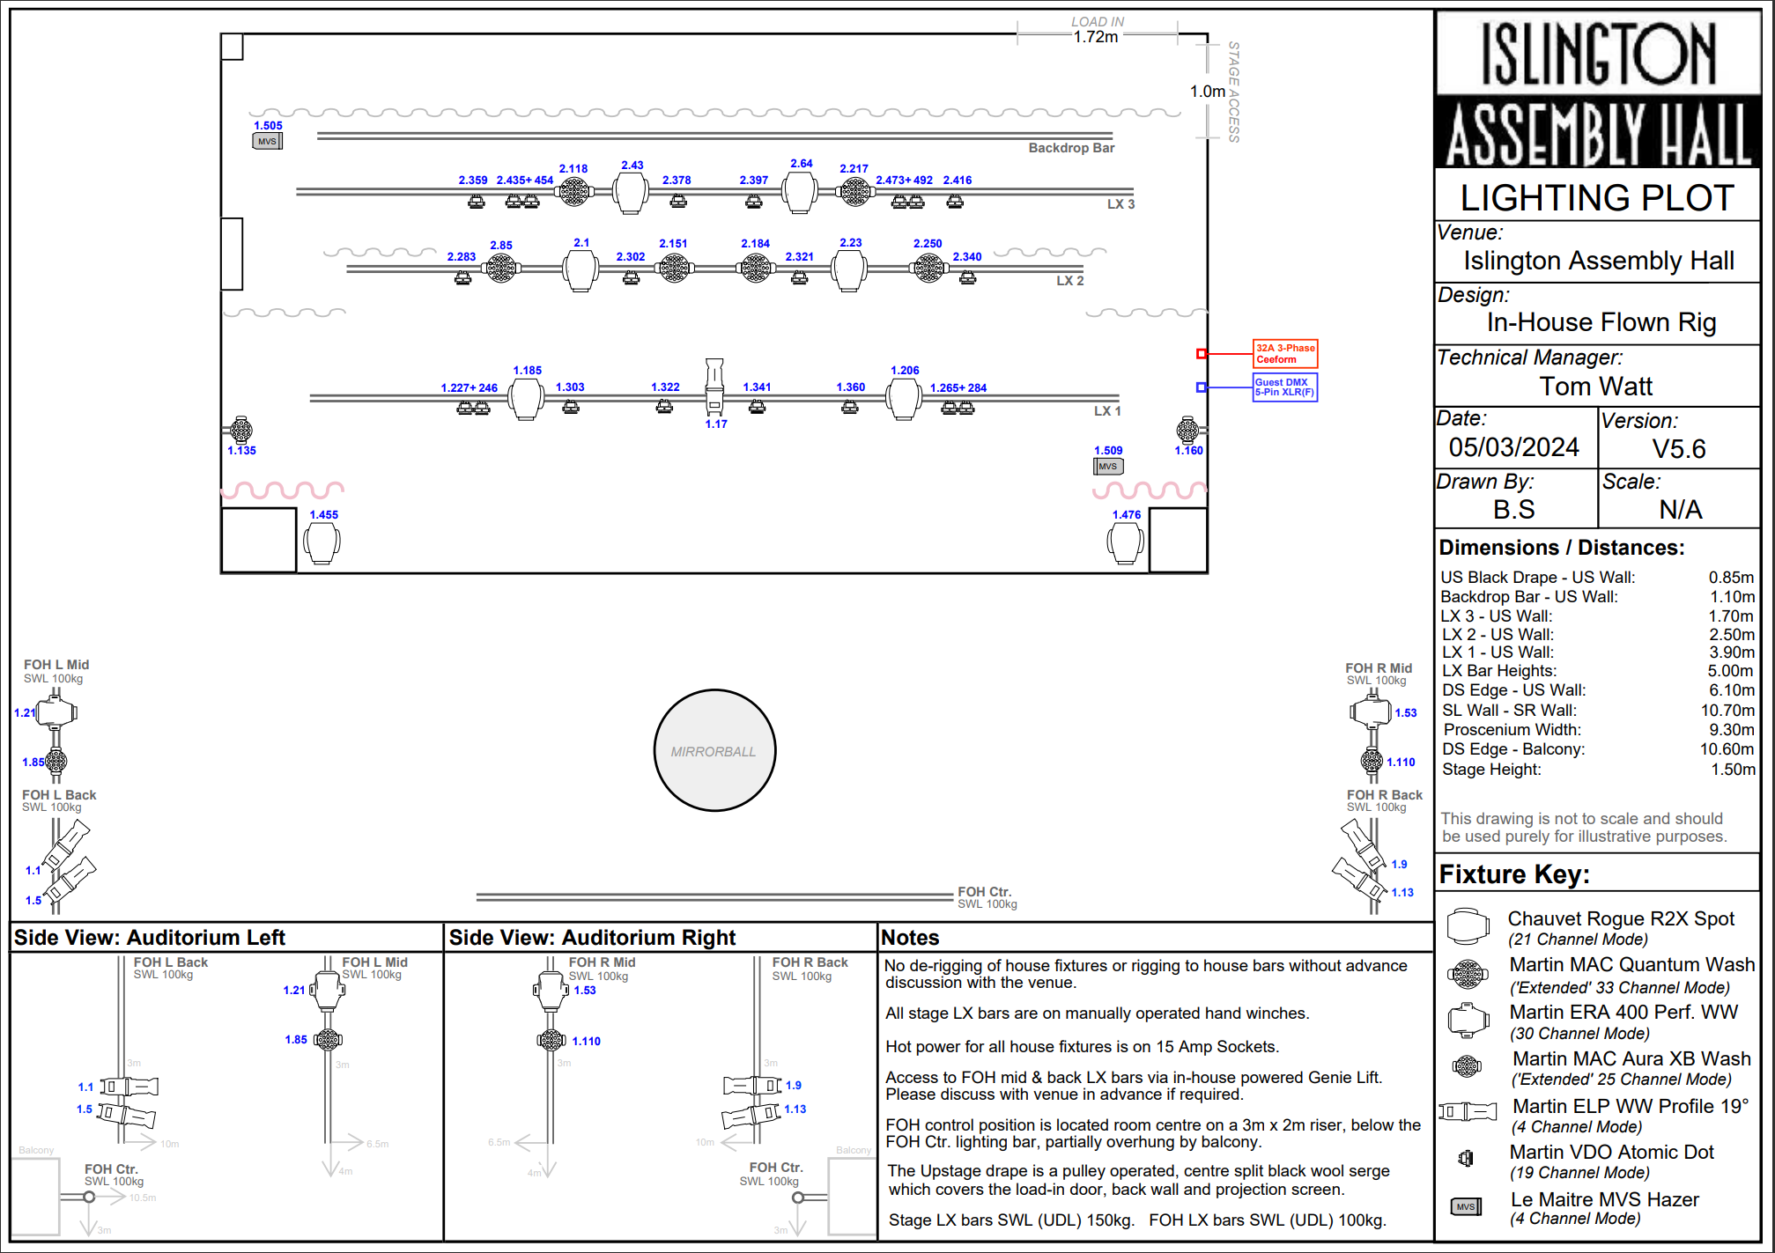
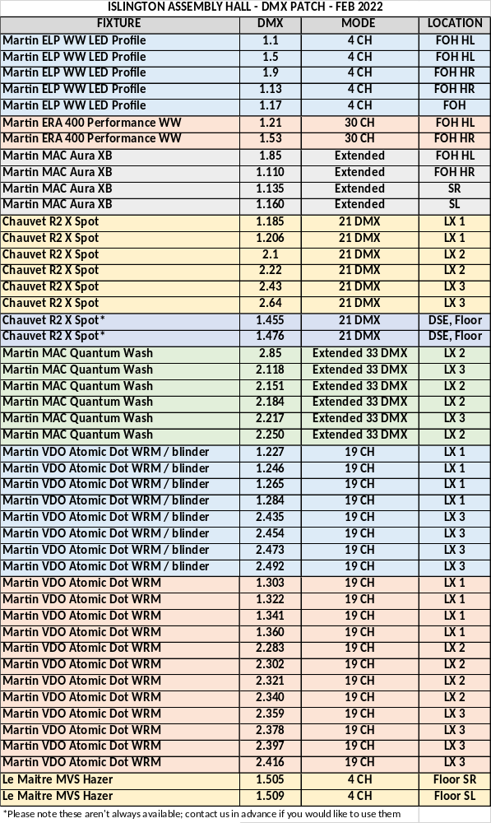
ISLINGTON ASSEMBLY HALL – STAGE PLAN